EmotionAI: A Multimodal Human Emotion Detection System for Real-Time Stress, Engagement and Empathy Analysis

Dr. Karthikeyan Periyasami School of computer science and Engineering R. V. University Bangalore, India karthikeyanp@rvu.edu.in
Maithri G School of Computer Science and Engineering R.V. University Bangalore, India maithrigbtech24@rvu.edu.in
Lochana K
School of Computer Science and Engineering
R.V. University
Bangalore, India
lochanakbtech24@rvu.edu.in
M Nandini
School of Computer Science and Engineering
R.V.University
Bangalore, India
mnandinibtech24@rvu.edu.in
Hema B L
School of Computer Science and Engineering
R.V. University
Bangalore, India
hemablbtech24@rvu.edu.in

Abstract— In the present days, Emotion recognition has become a very important component in modern human computer interaction. It is mainly useful in the fields of online education system, people mental health monitoring system, customer engagement in online shopping, corporate life meeting. The existing systems have single modalities like Either facial expression, voice or text, some have only two modalities like face+voice, voice+text. Almost all models developed for real time analysis. But in this model, it is available for real time analysis along with we can analyze by uploading images and voice note also. This model takes image, voice a text as input and classifies into seven emotion categories: angry, disgust, fear, happy, neutral, sad and surprise. This model is trained using 3 deep learning models independently, a Face CNN trained on FER2013 dataset which achieved 63.28% validation accuracy, a Voice CNN trained on the RAVDESS dataset achieving 71.81%, and a DistilBERT [2] model fine- tuned on ISEAR dataset which achieved 76.85% accuracy. These three are fused using Late Fusion Technology [2] and achieved a validation accuracy of 80.1%. The system also gives stress scores, engagement levels and empathy response suggestions from the fused output. It can be deployed as a real time web application accessible through browser interfaces.
Keywords— Multimodal Emotion Recognition, Deep Learning, Convolutional Neural Network, RAVDESS, FER2013, ISEAR, DistiBERT, Multimodal Fusion, Stress Detection, Engagement Analysis, Empathy Response.

IntroductioN
In recent days, the development of mobile devices and more frequent computer-based communication are mostly in the form of text messages, there is a need to communicate the emotions associated with the messages. The field of artificial intelligence (AI) is a prominent research domain in all the fields. Emotions are an integral part of human communication. It influences decision-making, behaviour of a person depending on their moods and Interaction with the society. Detecting and interpreting these emotions is an essential step toward creating emotionally intelligent systems that can naturally interact with the humans. The development of this type of system has applications in various domains like
Human mental health monitoring system, Online learning platforms, corporate meetings, Customer feedbacks in Shopping which represents a promising approach for enhancing student’s engagement and comprehension in studies. Entertainment sources, Customer-Service centre and Human-computer interactions. Human emotions are complex states that can be expressed through multiple ways like face expressions, voice tone and words that a person speaks or write. In face-to-face communications, human naturally understands about a person. As interactions slowly move to digital environments like online classes, video calls, chatbots, virtual AI assistant, digital meeting platforms, this natural understand becomes difficult. Sometimes it may be impossible for automated systems that depends on only one channel at a time.

If I take a specific real-life scenario like online education, a teacher interacts with many students through screen. They cannot easily detect whether a student is confused with the topics, not listening to class, stressed or not having a good health condition or happy. A student who looks normal in camera may having anxiety in voice, their written responses reflect sadness. Single modal systems only analyse only one of these may may lead to produce inaccurate assessments.

Multimodal emotion recognition gives a solution for this problem. It combines the input coming from different channels like face, voice, text simultaneously and gives fused output. Fused predictions give better outputs as compared to single modalities. Sometimes due to background noise or hardware issues in systems leads to reduced accuracy like camera may have poor quality but text and voice signals can still produce reliable result.

This paper presents EmotionAI, a real-time multimodal emotion detection system which is built using three different independently trained deep learning models. The Face CNN processes facial expression images captured from webcam and jpg, png uploaded images. The Voice CNN processes MFCC features [2] which taken from microphone and uploaded from files. The DistilBERT [2] model processes typed text and copied text from chats also. The outputs of all the three models are fused using a confidence based late fusion dynamic weighted averaging strategy that automatically adjust the contribution of each modal on the basis of how confident it is about prediction. Along with emotion classification, the system computes a stress score, an engagement score and generates an empathy-based response suggestion- making it an actionable tool.

In summary, this project gives us a knowledge about how deep learning modals help in bridging the communication gap between humans and machines by transforming emotional understanding into an emoji expression. It gives a strong foundation for future technical advancement in emoji aware artificial intelligence.

Literature survey
Multimodal emotion recognition has been developed more in recent years with the availability of different types of datasets.

Zhao et al. [1] proposed GS-MCC, a model for emotion recognition in conversations that gives solution to over-smoothing problem in graph neural network approaches. This model uses Fourier Graph Neural Network with low-pass and high-pass filters to capture emotion patters across a conversation. It evaluated on IEMOCAP and MELD benchmark datasets, GS-MCC performed in all existing methods by using 2.1 million parameters.

A survey by Khalil et al reviewed more than twelve popular datasets and categorized feature extraction methods: MFCC [2] for audio, BERT [2] for text and OpenFace for facial expressions. The survey organized fusion methods into Model- Agnostic Fusion, covering early, late and hybrid approaches and intermediate layer fusion, including concatenation, utterance level, fine grained interaction methods. This study tells that fine grained interaction fusion using transformers gives best accuracy.

Chen[4] proposed the CSS (Cross-Space Synergy) framework for multimodal emotion recognition in conversation. They identified two fundamental problems shallow fusion and gradient conflict between training objectives. This model evaluated on IEMOCAP and MELD using RoBERTa, OpenSMILE and DenseNet as feature encoders, CSS achieved accuracy of 75.42% and 68.47%.

Liu [5] observed the problem of missing modalities at test time by proposing M2S (multi-to-single). This model is basically trained on signals like EEG, ECG and eye movements. This model introduces two new technologies namely, STS attention and M2M CPC. After pre training with paired multimodal data and fine tuning with single modality, the model performed well.

Zhang [7] proposed UniMEEC, a framework that performs multimodal Emotion Recognition in conversations and Multimodal Cause Pair extraction using text, audio and visual signals. UniMEEc achieved 74.83% weighted F1 on IEMOCAP and 89.88% F1 on cause recognition.

Park [8] proposed MemoCMT which fuses speech and text using a cross-modal transformer. Here audio queries text and text queries audio through cross-attention. HuBERT is used for audio feature extraction and BERT for text. MIN aggregation is applied to the fused matrix to capture emotional signals. MemoCMT achieved 81.22% accuracy on IEMOCAP and 91.93% on ESD and performed well as compare to other existing models.

Additional relevant works also done related to this projects which gives an idea about how Multimodal emotion recognition is grown gradually as the year passes. However, most of the existing models are evaluated but not designed for practical real-world usage. EmotionAI gives solution to this problem by developing a deployable multimodal system which has webcam, microphone and text feature.

Methodology
To build this model three different separate datasets are used. Each dataset represents one modality. In fusion, all emotion label gives 7 emotions: angry, disgust, fear, sad, neutral, sad and surprise.

Dataset Preparation
Face Dataset – FER style: For analyzing facial expression we chose FER2013 from Kaggle which has 7 emotions. All the emotions are divided into train and test folder. All images are resized to 64*64 pixels and normalized using mean and standard deviation. Data augmentation techniques like flipping, rotation applied to improve the generalization of the model. This data also has some imbalance like more images for happy and less images for disgust. This problem gives a little effect in achieving good accuracy.

Voice Dataset – RAVDESS: The Ryerson Audio Visual Database of Emotional Speech and Song (RAVDESS). It contains 1440 audio recordings which is taken from 12 male and 12 female actors. MFCC [2] (Mel Frequency Cepstral Coefficients) features were extracted from audio files using librosa. This MFCC can convert the non-hearable frequency to hearable frequency by using FFT [1] and DCT. Short recordings were zero padded and long recordings were truncated to maintain uniformity in inputs.

Text Dataset – ISEAR: The International Survey on Emotion Antecedents and Reactions (ISEAR) dataset contains text descriptions of emotional situations. All text was lowercased and cleaned before tokenization using the DistilBERT [2] tokenizer with a maximum sequence length of 128 tokens.

Model Architecture
Face CNN: To identify the facial expression, FER dataset is trained used Custom Convolutional Neural Network (CNN). It has 4 convolutional blocks. Each block has a Conv2D layer, Batch normalization, ReLU activation function and max pooling with stride 2. The number of feature map progresses from 32, 64, 128 and 256 among all four blocks. After convolutional blocks, the feature maps are flattened and passed to fully connected layer with 512 units and ReLU activation and next it passes to another fully connected layer with seven output units. Drop regularization mechanism is applied which randomly disables some neurons to prevent overfitting. The input size is 64*64*3 and the output is 7-dimensional vector which uses softmax activation function.

Voice CNN: The Voice CNN treats MFCC [2] spectrograms as a single channel image. It uses a convolutional architecture to extract patterns. This contains three convolutional blocks with Batch normalization and ReLU activation function. It has Adaptive average pooling that fixes the output size without considering input length.

DistilBERT Text model: DistilBERT is an updated version of BERT that retrains 97% of BERT’s language. The pretrained distilbert model was loaded from Hugging Face Transforms. The seven output neurons were added on top of the pooled output. The model was fine tuned for 5 epochs on the ISEAR dataset using the AdamW optimizer. In AdamW, W stands for Weight decay, which decreases the weight and helps the model to learn the patters instead of memorizing.

Fig 1: Model Architecture
FACE
Webcam/ Image Upload
VOICE
Recording/ Audio
TEXT
Typed/copied sentence
DistilBERT fine – tuned NLP from Hugging face

Voice CNN
MFCC Feature Extraction
FACE CNN
Four convolutional layers

angry, disgust, fear, happy, neutral, sad, surprise
angry, disgust, fear, happy, neutral, sad, surprise
angry, disgust, fear, happy, neutral, sad, surprise

Late Fusion Technology
(Decision Level Fusion)

Detected Emotion with Confidence Score

Stress analysis and Engagement Score
Empathy Response Generation

Emotion Detection and Emoji Generation
Face data is trained using CNN. The output layer has 7 output neurons which maps to 7 corresponding emotions. The emotion which has highest probability is considered for fusion. The Voice data is also trained using CNN. MFCC extracts the features from the voice. MFCC is a way to convert the given raw data into numbers. It only listens to the sound regardless of what words are in input. Its main work is to concentrate on tone only. MFCC [2] co efficient is set to 40.Text data is trained using a pre-trained natural language programming model, DistilBERT which is imported from Hugging Face. DistilBERT tokenizers are imported to convert the text into numbers.

Deployment
This model is built as a full stack web application. For backend connection, we used FastAPI which is a modern python framework most commonly used in web applications. It is running on a local host port 8000. One POST request handles multiple files like image, voice and text input. The backend takes all the input, runs the interface through all three modalities, performs fusion action, calculates stress and engagement score. It also generates an empathy response and gives a structured response to user.

To build frontend, we used HTML5, CSS3 and vanilla JavaScript. It has two types of input taking mechanism. In live analysis mode, webcam captures the real time image, microphone records the audio. Facial frames are captured from live video analysis. In upload mode, users can upload saved images and audios along with text for offline analysis.

The Web Speech API is used to listen the real time audio and convert it into text. It helps the user to know about what they said and what model listen. Result section displays detected emotion along with emoji, confidence percentage, probability distribution chart of all the seven emotions, stress and engagement percentage and an empathy message. It also shows how much each modalities contributed to get the fused result.

Results and discussion
- Dataset Distribution
The facial dataset has a quiet imbalance in detecting one emotion. The happy class contain more samples whereas the disgust class has very fewer samples which can cause model while predicting disgust. The RAVDESS dataset is almost balanced in all the classes because of its more
professional recording setup. The ISEAR text dataset shows balance across the seven emotion categories with a little variation in rare cases.

- Model Training and Accuracy.
The FaceCNN is trained for 50 epochs on FER2013 dataset. In first epoch, the training loss is 1.53. It decreased to 0.7 in 50th epoch. The training and testing accuracy curves are almost close. The model is generalized well without overfitting.

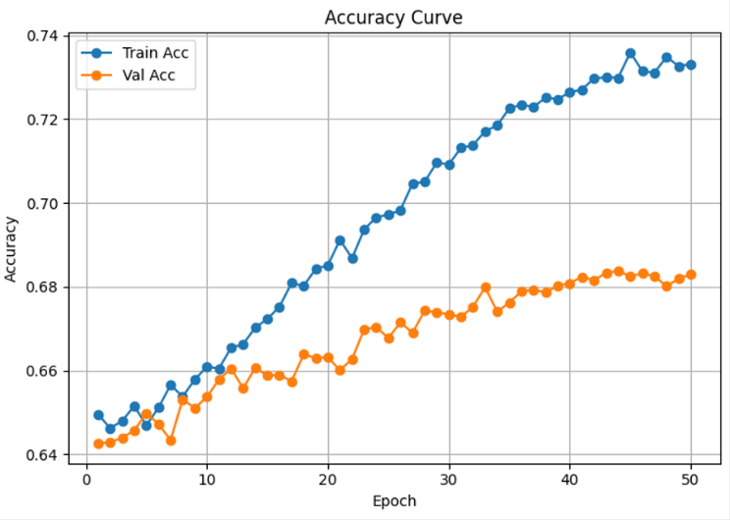
Fig 2: Face CNN Accuracy Curve

The voice dataset is trained for 40 epochs on MFCC features taken from RAVDESS dataset. In 1st epoch, the validation accuracy was almost 25% but it improved to 71.18% in epoch 40. During training the model, we faced some issues and more loss which is due to small size of dataset. Training accuracy reached almost 80% but validation accuracy is still 715 which tells about the small chance of overfitting. Sometimes the input has very small size or very big, it leads to inconsistency while predicting the emotions. So, we se the padding to 174 frames. The frames less than 174 will be padded with zero on right side. The frames which have more than 174 frames will be truncated.

Why 174...?
Formula: (duration of RAVDESS * Sample Rate) / hoplength

For RAVDESS duration is from 3.5 to 4s.

(3.5 * 22050) / 512
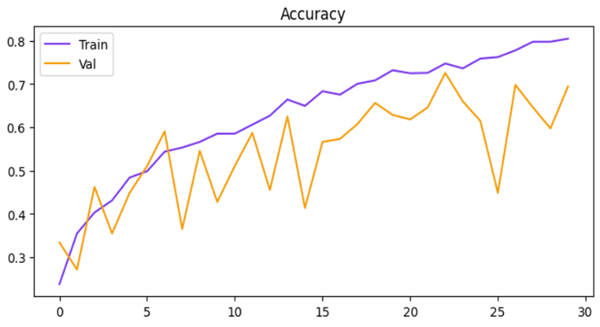
Ans: 174

Fig 3: Voice CNN Accuracy Curve

DistilBERT is trained for 5 epochs on the ISEAR dataset. It is already a pre trained model taking from Hugging Face. In beginnings, we got accuracy as 71% and while reaching for last epoch the accuracy improved to 76.85%. Training accuracy reached 90% but validation accuracy is in between 76% to 77%. Here we used AdamW to prevent the overfitting of the model. In ISEAR dataset so many textual features are there. We selected only those emotions which relates to our model [ 7 basic emotions are taken]

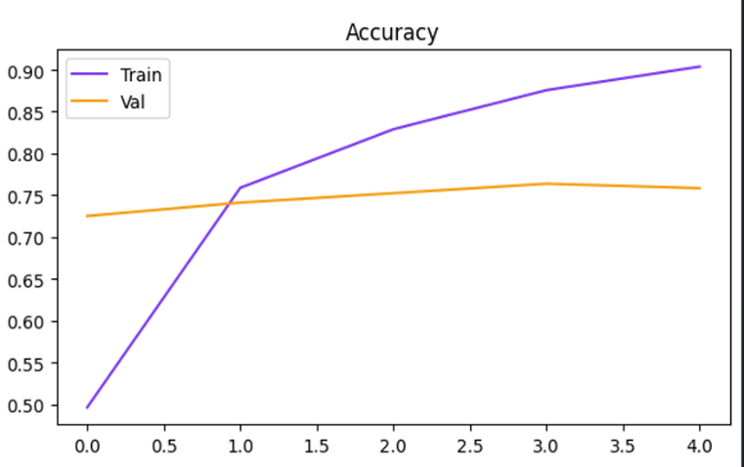
Fig 3: Text DisttlBERT Accuracy Curve

- Performance Evaluation.
The confusion matrix of the Face CNN talks about the performance of trained model. The happy class has highest number of correct predictions at 1517, neutral 807 and surprise 646. The sad class correctly predicted 658 and fear class has 353 correct predictions. A common limitation of FER dataset is sometimes the fear expressions relates with sadness also. The disgust class has poor performance of facial expression because of its very less (19) number of samples. Even though it has noisy data, it is performing well on unsees data by correctly predicting the emotions. Voice data is extracted using MFCC feature. For our convenience we set the MFCC co-efficient to 40 it can be change also. It mainly concentrates only on voice tone which it received and predicts the appropriate emotion and contributes to fusion engine. DistilBERT tokenizer converts the text into numbers and predicts the output. All the three models are trained independently. Before sending the probability predictions to fusion engine, we have three different outputs.

For fusion, we used Late fusion technology. It takes the three inputs and combines on the basis of given weights and gives final fused output with a confidence score. Along with this it will give stress level, engagement and empathy response. To predict this, we generally assigned values in the code. The stress score is calculated as a weighted dot product of the fused emotions probability. The weights used are fear = 0.90, angry = 0.85, disgust = 0.60, sad = 0.50, surprise = 0.30, neutral = 0.05, happy = 0.00. The engagement score is calculated similarly using: happy = 0.90, surprise = 0.85, angry = 0.70, fear = 0.60, disgust = 0.50, sad = 0.20, neutral = 0.00 Both scores are in the range on 0 and 1.

Stress Score Formula:
Stress = Σ (stress_weight_i * fused_prob_i)

Engagement Score Formula:
Engagement = Σ (engagement_weight_i * fused_prob_i)

*Real Life Implementation:
The model EmotionAI is tested in real life conditions using laptop which has built in webcam, integrated microphone and keyboard for text input. No hardware is needed for this. This system entirely runs on CPU no GPU or high-power processors are needed. The response time is almost 1-2 seconds. This model is tested on different scenarios like giving happy expression, sweet tone and positive text, all detected happy and gave fused output as happy with high confidence score with minimal stress level and corresponding empathy response is also generated. We also worked on conflicted modalities like happy face, little rough voice and sad text. For this type of input also model worked well and gave expected fused emotion along with other features. For testing the behavior of system, we gave single outputs like only face, voice or text. The fusion engine handled this case properly and given output. We gave input live face+text, voice+face, model handled this also well. Based on all the scenerios tested, we got some key findings. In most of cases text emotion is dominated due to its high accuracy as compare to voice and face. The accuracy of voice is mainly based on the speaking styles of a person not on the spoken words. Stress and Engagement scores are almost correct in all the test cases.

CONCLUSION
This paper EmotionAI, a real time multimodal emotion recognition detection system that combines face, voice and text as input and gives a fused output using three different independently trained deep learning models. The Face CNN has 63.28% accuracy; Voice CNN has 71.18% and DistilBERT has 76.85% accuracy. These three models are combined using Late Fusion Technology, confidence based dynamic weighting averaging strategy. It achieved a good accuracy of 79 to 80%. Beyond this, the system also analyses stress level, engagement score and empathy-based response suggestions. This model transforming the system from a simple classifier to an actionable tool. The deployment as a lightweight web application using Fast API demonstrates that multimodal emotion systems can be made available to users.
This system has real world application in various domains like online education for monitoring students stress and engagement level, in mental health platforms for detecting stress, in customer service for enabling empathetic response in corporate meetings to know about how the people are working and in shopping to observe the true feedback of the people.

FUTURE SCOPE
As far now our model is working well. To improve this in upcoming days we have some ideas. Replacing the Voice CNN with transformer-based audio like Wav2Vec 2.0 or HuBERT helps in improving the accuracy. Presently the model is taking only English language, in future it can be made to analyze some more language and convert it into machine understandable language makes better.

Training the face model on other datasets that has more features like age, gender and with accessories such as glass, mask would help to remove bias and increase the accuracy. It can be also extended to detect multiple faces at one time. Real time face analysis like how emotion is varying across the time

Implementing a session tracker to track the emotions of students in overall sessions. By this we can analyze that whether emotion state of students is declining or improving.
We can generate a report of overall session. Taking more advanced fusion algorithms such as cross modal transformer, Hybrid fusion transformer, graph-based fusions help to improve modalities. API keys can be used to generate automatic empathy response based on the situation. For now, we created a .env file and an API key. Due to its credits and all restricts we did not implement it in our model. Finally, optimizing the models and deploying on the mobile and edge devices can extend this system to people where laptop/desktop is not allowed.

References
- Ai, W., Zhang, F., Shou, Y., Meng, T., Chen, H., & Li, K. (2025). Revisiting Multimodal Emotion Recognition in Conversation from the Perspective of Graph Spectrum. Proceedings of the AAAI Conference on Artificial Intelligence, 39(11), 11418-11426

- Lian H, Lu C, Li S, Zhao Y, Tang C, Zong Y. A Survey of Deep Learning-Based Multimodal Emotion Recognition: Speech, Text, and Face. Entropy (Basel). 2023 Oct 12;25(10):1440. doi: 10.3390/e25101440. PMID: 37895561; PMCID: PMC10606253.

- Wu Y, Mi Q, Gao T. A Comprehensive Review of Multimodal Emotion Recognition: Techniques, Challenges, and Future Directions. Biomimetics (Basel). 2025 Jun 27;10(7):418. doi: 10.3390/biomimetics10070418. PMID: 40710231; PMCID: PMC12292624.

- Cross-Space Synergy: A Unified framework for multimodal emotion recognition in convversation.arXiv:2512.03521v3

- Liu, Y.-K., Cai, J., Lu, B.-L., & Zheng, W.-L. (2025). Multi-to-Single: Reducing Multimodal Dependency in Emotion Recognition Through Contrastive Learning. Proceedings of the AAAI Conference on ArtificialIntelligence, 39(2),1438-1446. https://doi.org/10.1609/aaai.v39i2.32134

- Wang, Y., Fang, X., Yin, H., Li, D., Li, G., Xu, Q., Xu, Y., Zhong, S., & Xu, M. (2025). BIG-FUSION: Brain-Inspired Global-Local Context Fusion Framework for Multimodal Emotion Recognition in Conversations. Proceedings of the AAAI Conference on Artificial Intelligence, 39(2), 1574-1582. https://doi.org/10.1609/aaai.v39i2.32149

- Guimin Hu, Zhihong Zhu, Daniel Hershcovich, Lijie Hu, Hasti Seifi, and Jiayuan Xie. 2024. UniMEEC: Towards Unified Multimodal Emotion Recognition and Emotion Cause. In Findings of the Association for Computational Linguistics: EMNLP 2024, pages 5248–5261, Miami, Florida, USA. Association for Computational Linguistics.

- Khan, M., Tran, PN., Pham, N.T. et al. MemoCMT: multimodal emotion recognition using cross-modal transformer-based feature fusion. Sci Rep 15, 5473 (2025). https://doi.org/10.1038/s41598-025-89202-x

- Gupta, C., Gill, N.S., Gulia, P. et al. A multimodal fusion model for real-time environment emotion recognition using audio-visual-textual features. J Big Data 12, 256 (2025).https://doi,org/10.1186/s40537-025-01300-9

[10] Wang, H., Shi, Z., Hu, R. et al. Real-time fear emotion recognition in mice based on multimodal data fusion. Sci Rep 15, 11797 (2025). https://doi.org/10.1038/s41598-025-95483-z
- Junchi, M., Chaudhry, H.N., Kulsoom, F. et al. MULTICAUSENET temporal attention for multimodal emotion cause pair extraction. Sci Rep 15, 19372 (2025). https://doi.org/10.1038/s41598-025-01221-w

- Kusal, S., Patil, S. & Kotecha, K. Multimodal text-emoji fusion using deep neural networks for text-based emotion detection in online communication. J Big Data 12, 32 (2025). https://doi.org/10.1186/s40537-025-01062-4
- Sangeetha, S., Boddu, R.S.K., Bhaumik, A. et al. Spatiotemporal multimodal emotion recognition using Temporal video sequences and pose features for child emotion classification. Sci Rep 15, 41825 (2025). https://doi.org/10.1038/s41598-025-25813-8

